

**Product Dissection for Zerodha**

**Company Overview:**

Zerodha is a pioneering Indian discount brokerage and financial services company founded in 2010 by Nithin and Nikhil Kamath. Headquartered in Bengaluru, Zerodha offers an electronic trading platform for a wide range of assets, including stocks, equity derivatives, commodities, currencies, bonds, and mutual funds. It has grown rapidly to become one of India’s largest stockbrokers, with over 7.5 million active customers as of 2024 and contributing ~15% of daily retail trading volumes in India.

Zerodha’s core platforms include:

* *Kite* – a sleek and intuitive trading interface (web + mobile)
* *Console* – a back-office dashboard for reports, portfolio analytics, and P&L statements
* *Coin* – a platform to invest in direct mutual funds with 0% commission
* *Varsity* – an open education initiative to help users learn about the stock market

**Product Dissection and Real-World Problems Solved by Zerodha:**

Zerodha has transformed the Indian stock trading landscape by solving multiple challenges faced by retail investors through its innovative product design. One of the most significant problems it addressed was the high cost of trading. Traditional brokers charged percentage-based brokerage, making frequent trading expensive and inaccessible for small investors. Zerodha introduced a game-changing flat-fee pricing model, offering ₹0 brokerage on equity delivery and a maximum of ₹20 on intraday and F&O trades, significantly reducing the cost burden for users.

Another major issue was the lack of transparency in fee structures and trade reports. Many investors struggled to understand hidden charges and navigate complex contract notes. Zerodha tackled this by offering complete transparency through its detailed trade breakdowns on the Console platform and an easy-to-use brokerage calculator. Users can now see exactly what they’re being charged, building trust and eliminating confusion.

Legacy trading platforms in India were often difficult to use, cluttered, and not beginner-friendly. Zerodha’s Kite platform solved this with a minimalist and intuitive interface, allowing users to search for stocks quickly, view real-time market data, and place trades seamlessly. This simplified experience made stock trading more approachable for first-time investors.

Lastly, tracking investment performance and calculating true returns was a daunting task, especially when accounting for events like stock splits, bonuses, and dividends. Zerodha addressed this through the Console dashboard, which automatically updates user holdings and provides a “True P&L” view. It also offers tax-ready reports and visual insights, eliminating the need for manual tracking and simplifying financial reporting. Overall, Zerodha’s feature-rich ecosystem directly solves user pain points with smart, user-centric design.

# **Case Study: Real-World Problems and Zerodha Innovative Solutions**

# Zerodha addresses critical challenges in the Indian trading and investment landscape through its tech-driven, user-focused solutions. By simplifying trading, cutting costs, and enhancing transparency, Zerodha empowers millions of retail investors to participate confidently in the stock market.

**Problem 1: High Brokerage Costs in Traditional Trading**

**Real-World Challenge:**

Retail traders often faced excessive brokerage fees under traditional models, which charged a percentage of the trade value. This made frequent trading costly and discouraged small investors from participating actively in the market.

**Zerodha’s Solution:**

Introduced a flat ₹20 brokerage on intraday and F&O trades and ₹0 brokerage on equity delivery. This pricing model makes trading affordable and transparent, encouraging greater participation from retail investors and improving profitability for active traders.

**Problem 2: Lack of Transparency in Charges and Reports**

**Real-World Challenge:** Investors struggled to understand the various hidden charges in their contract notes and found it difficult to track their actual costs and profits across trades.

**Zerodha’s Solution:**

Offers detailed trade reports and brokerage calculators via the Console platform, providing complete cost breakdowns. Every charge, from taxes to exchange fees, is itemized, improving trust and clarity for users.

**Problem 3: Complex and Cluttered Trading Interfaces**

**Real-World Challenge:** Many legacy platforms used by traditional brokers were difficult to navigate, especially for first-time users. These platforms lacked user-friendly design, causing confusion and trading errors.

**Zerodha’s Solution:**

Launched Kite, a minimalistic and intuitive trading platform offering a smooth user experience. It includes universal stock search, real-time data, drag-and-drop watchlists, and advanced charting tools - making trading easy even for beginners.

**Problem 4: Difficulty in Tracking Investment Performance and Tax Reporting**

**Real-World Challenge:** Users often struggled to calculate their true returns, especially after events like dividends, stock splits, and bonuses. Tax season was even more stressful due to manual report consolidation.

**Zerodha’s Solution:**

Provides a “True P&L” feature through Console that automatically adjusts for corporate actions. It also generates tax-ready capital gains reports, trade summaries, and visual insights - helping users manage and track their portfolio effortlessly.

**Problem 5: Risky Trading Habits Among Beginners**

**Real-World Challenge:** Many new traders, due to lack of experience, engage in risky trades, often investing in illiquid or volatile stocks without understanding the consequences.

**Zerodha’s Solution:**

Introduced the Nudge feature, which alerts users when they are about to place risky or non-compliant trades. Combined with the Kill Switch (which allows users to temporarily disable segments), Zerodha actively promotes safer and more responsible trading behavior.

**Problem 6: Limited Access to Direct Mutual Funds**

**Real-World Challenge:**

Many investors unknowingly purchased mutual funds through intermediaries who charged commissions, which reduced long-term gains. There was also low awareness about direct mutual fund plans offering better returns.

**Zerodha’s Solution:**

Through its Coin platform, Zerodha enables users to invest in direct mutual funds with zero commission. All investments are held in the user’s demat account, ensuring transparency, better control, and higher returns over time.

**Problem 7: Difficulty for Developers to Build Custom Solutions**

**Real-World Challenge:**

Fintech startups and advanced traders often needed to automate trading strategies or create personalized dashboards, but traditional brokers did not offer public APIs or integration options.

**Zerodha’s Solution:**

Zerodha introduced Kite Connect APIs, which allow developers to build custom apps and trading tools. This has led to a growing ecosystem of integrated platforms like smallcase (thematic investing), Streak (strategy automation), and Sensibull (options trading), all connected to Zerodha’s backend.

**Problem 8: Lack of Financial Literacy Among Retail Investors**

**Real-World Challenge:**

New investors often lacked a clear understanding of stock market fundamentals, which resulted in confusion, fear of loss, and poor decision-making.

**Zerodha’s Solution:**

Zerodha launched Varsity, a free and structured learning platform covering everything from stock market basics to advanced trading strategies. Additionally, the TradingQnA community forum allows users to ask questions, learn from peers, and stay updated on market trends.

**Top Features of Zerodha**

# 1. **Kite Trading Platform (Web & Mobile):**

# A minimalist and intuitive platform that allows users to trade in stocks, derivatives, commodities, and currencies. It features real-time data, instant search across 90,000+ instruments, and advanced charting with hundreds of indicators.

2. **Console – Portfolio and Analytics Dashboard:**

A comprehensive back-office tool where users can track their investments, view profit and loss statements, download tax reports, and get insights into trading performance with clear visualizations.

3. **Direct Mutual Fund Investing via Coin:**

Zerodha Coin enables users to invest in direct mutual funds with zero commission. All holdings are in the user’s demat account, offering transparency, long-term savings, and easy tracking in one place.

4. **Good Till Triggered (GTT) Orders and Basket Orders:**

GTT orders allow users to set buy/sell triggers for stocks that remain active until conditions are met. Basket orders enable execution of multiple trades together, useful for strategy-based investing.

5. **Kite Connect API for Developers:**

An open API gateway that allows fintech developers and advanced users to build custom trading tools, dashboards, or automated strategies, enabling a wide range of innovation in stock market applications.

6. **Nudge and Kill Switch – Risk Control Tools:**

Nudge warns users before placing risky trades (like buying illiquid stocks or over-leveraging), while Kill Switch allows users to temporarily disable trading in certain segments, promoting disciplined and safer trading behavior.

7. **Varsity and TradingQnA – Education & Community:**

Zerodha Varsity offers free, in-depth market education from beginner to advanced levels. TradingQnA is a community forum where users can ask questions, share knowledge, and stay updated with the latest trading discussions.

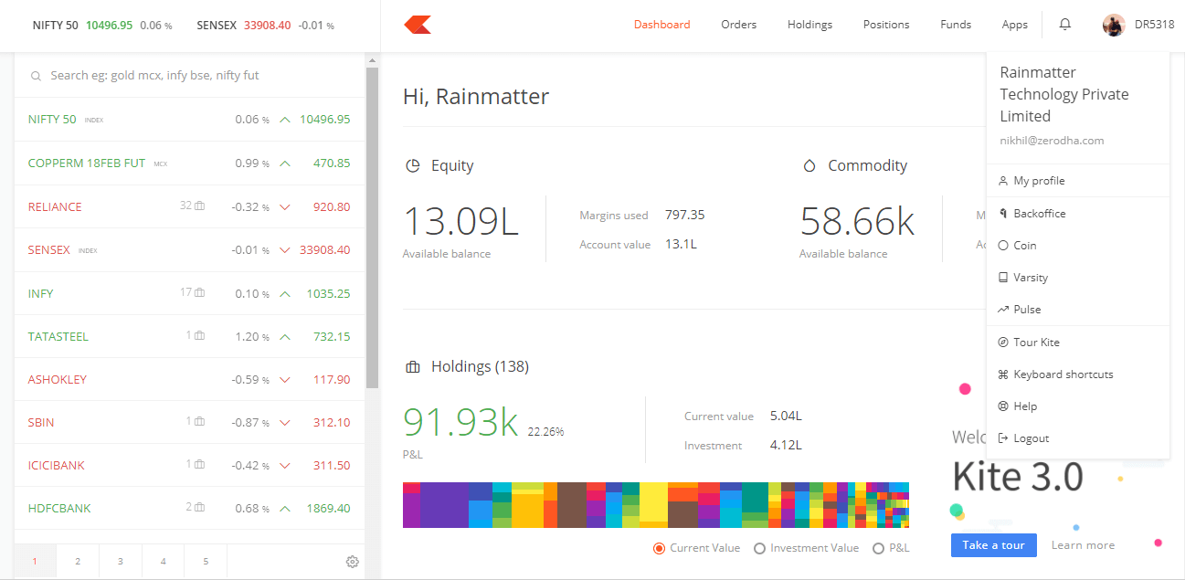

*Zerodha’s Kite dashboard showcasing real-time portfolio, equity, and commodity positions with a clean and user-friendly interface.*

**Schema Description**

The schema for Zerodha captures the essential entities and relationships needed to manage user accounts, stock transactions, holdings, and trading operations efficiently and transparently.

**Users Entity**

* **UserId (Primary Key):** Unique identifier for each user.
* **FullName:** Full name of the user.
* **Email:** Registered email address.
* **PhoneNumber:** Contact number for account verification and notifications.
* **AccountType:** Investor or Trader.
* **PANNumber:** User’s PAN card number (for regulatory compliance).
* **RegistrationDate:** The date the user created the account.

**Stocks Entity**

* **StockId (Primary Key):** Unique identifier for each stock or instrument.
* **Symbol:** Ticker symbol (e.g., TCS, INFY).
* **CompanyName:** Name of the company.
* **Exchange:** Exchange where the stock is listed (e.g., NSE, BSE).
* **InstrumentType:** Type of instrument (Equity, Futures, Options, ETF, etc.).
* **CurrentPrice:** Latest market price.

**Orders Entity**

* **OrderId (Primary Key):** Unique identifier for each order placed.
* **UserId (Foreign Key referencing Users Entity):** User who placed the order.
* **StockId (Foreign Key referencing Stocks Entity):** Stock being traded.
* **OrderType:** Buy or Sell.
* **OrderMode:** Market, Limit, Stop-loss, GTT.
* **Quantity:** Number of shares.
* **Price:** Price at which the order is placed.
* **OrderStatus:** Executed, Partially Filled, Pending, Cancelled.
* **OrderDate:** Date and time of order placement.

**Trades Entity**

* **TradeId (Primary Key):** Unique identifier for each trade (executed order).
* **OrderId (Foreign Key referencing Orders Entity):** Order that triggered the trade.
* **ExecutedQuantity:** Quantity executed in this trade.
* **ExecutedPrice:** Final execution price.
* **TradeType:** Buy or Sell.
* **TradeTime:** Date and time when the trade was executed.

**Holdings Entity**

* **HoldingId (Primary Key):** Unique ID for each holding.
* **UserId (Foreign Key referencing Users Entity):** User who owns the holding.
* **StockId (Foreign Key referencing Stocks Entity):** Stock being held.
* **QuantityHeld:** Total number of shares currently held.
* **AverageBuyPrice:** Average price of acquisition.
* **LastUpdated:** Timestamp of last update in holding (due to new trade or corporate action).

**FundTransactions Entity**

* **TransactionId (Primary Key):** Unique identifier for each fund transaction.
* **UserId (Foreign Key referencing Users Entity):** User initiating the transaction.
* **TransactionDate:** Date of transaction.
* **TransactionAmount:** Amount deposited, withdrawn, or adjusted.
* **TransactionType:** Deposit, Withdrawal, Trade Debit, Trade Credit, Charges.
* **TransactionStatus:** Success, Failed, Pending.
* **Remarks:** Description or notes (e.g., “UPI Deposit”, “Brokerage Fee”).

**Watchlist Entity**

* **WatchlistId (Primary Key):** Unique identifier for each watchlist entry.
* **UserId (Foreign Key referencing Users Entity):** User who added the stock to watchlist.
* **StockId (Foreign Key referencing Stocks Entity):** Stock being watched.
* **AddedDate:** Date the stock was added to watchlist.

**Alerts Entity**

* **AlertId (Primary Key):** Unique identifier for each price alert.
* **UserId (Foreign Key referencing Users Entity):** User setting the alert.
* **StockId (Foreign Key referencing Stocks Entity):** Stock for which alert is set.
* **TargetPrice:** Price at which alert is triggered.
* **AlertStatus:** Triggered, Active, Expired.

**Relationships are:**

* **Users place Orders** – Each user can place multiple orders, but each order is tied to one user.
* **Orders are placed for Stocks** – Each order is linked to one stock, but a stock can have multiple orders.
* **Orders result in Trades** – A single order can be executed in multiple parts (multiple trades).
* **Users hold Stocks** – A user can hold multiple stocks; a stock can be held by multiple users (via Holdings).
* **Users perform Fund Transactions** – Each fund transaction (deposit/withdrawal) is linked to one user.
* **Users create Watchlists** – Each user can add multiple stocks to their watchlist.
* **Users set Alerts** – A user can set alerts for price movements of various stocks.

**ER-Diagram:**

Let's construct an ER diagram for Zerodha visually represents the key entities and their relationships within the platform, including users, orders, trades, stocks, holdings, alerts, and fund transactions. It highlights how users interact with the system to place trades, manage portfolios, and track stock activity. This diagram provides a clear understanding of the platform’s data structure and the flow of information across its core modules.

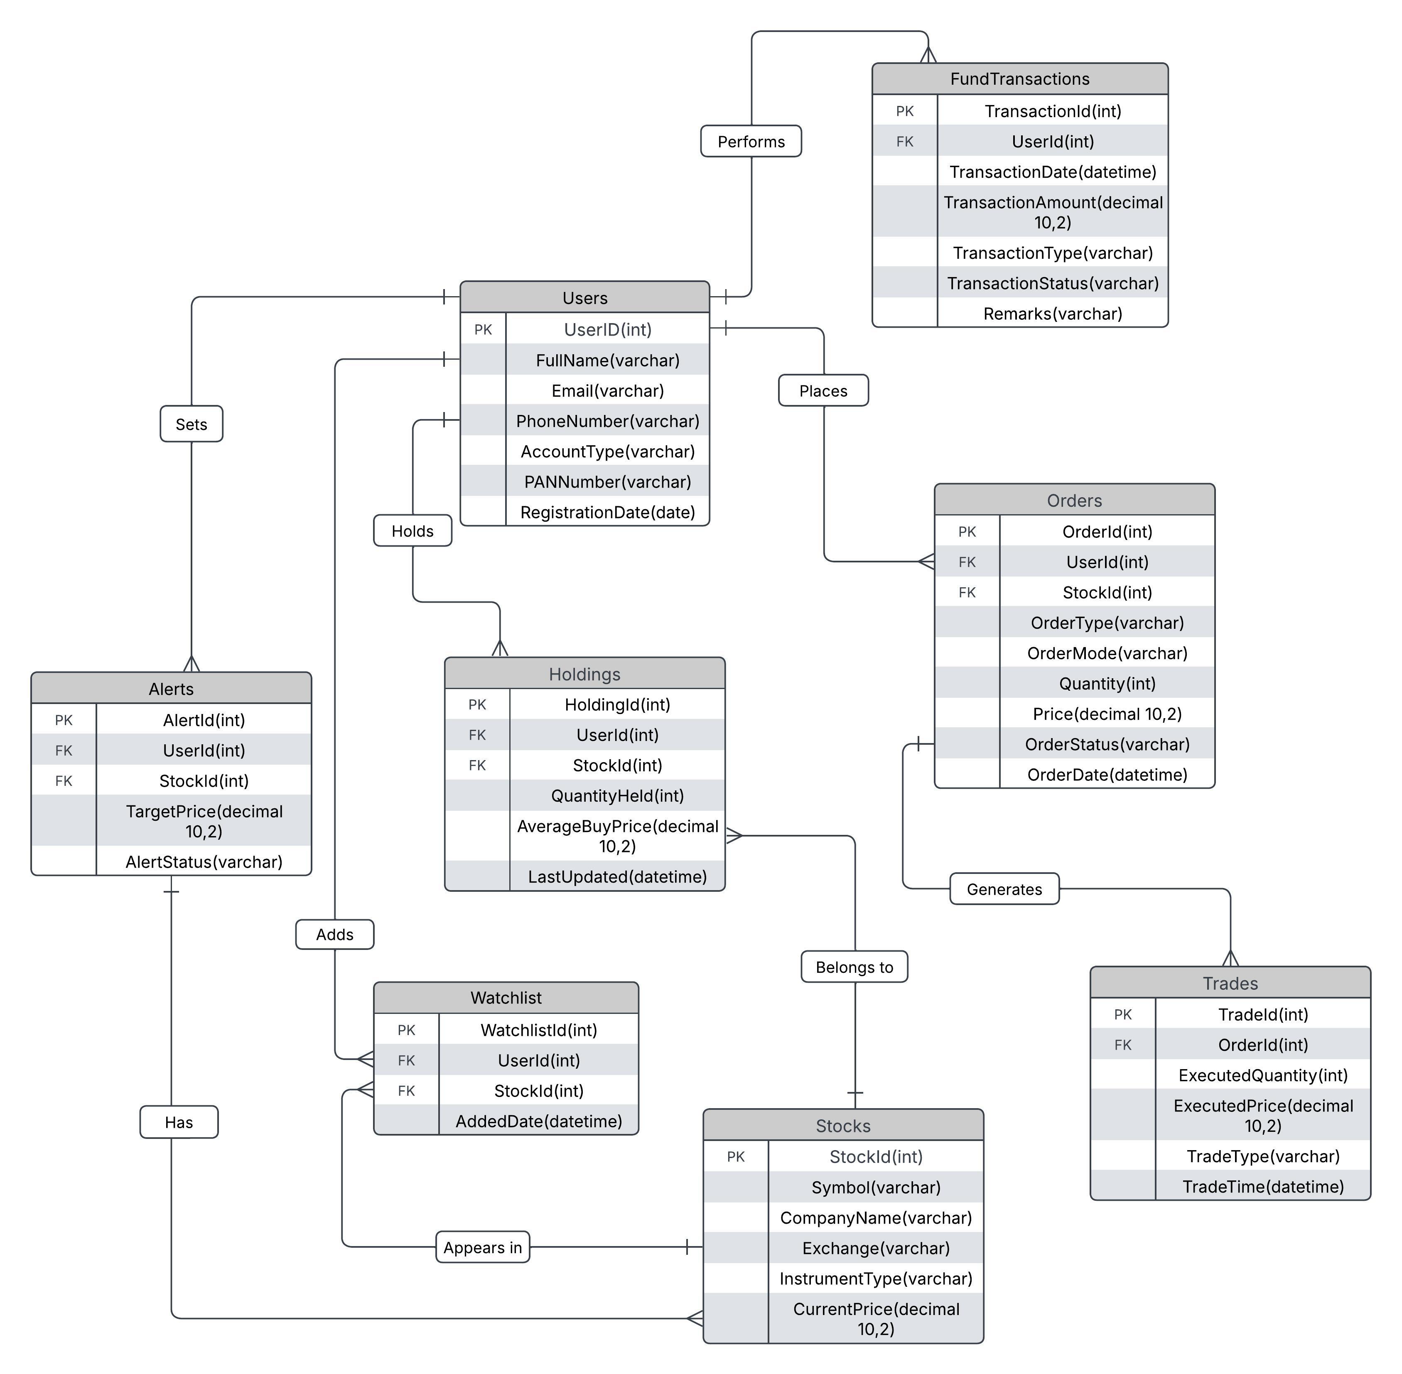

**Conclusion**

Zerodha stands out as a disruptive force in the Indian stock trading ecosystem, driven by its user-centric design, transparent pricing, and powerful technological infrastructure. Through this analysis and ER diagram, we’ve unpacked how its core features and backend data model work seamlessly to deliver a streamlined, reliable, and scalable trading experience. Zerodha’s innovation not only simplifies investing but also empowers millions to take control of their financial journey.